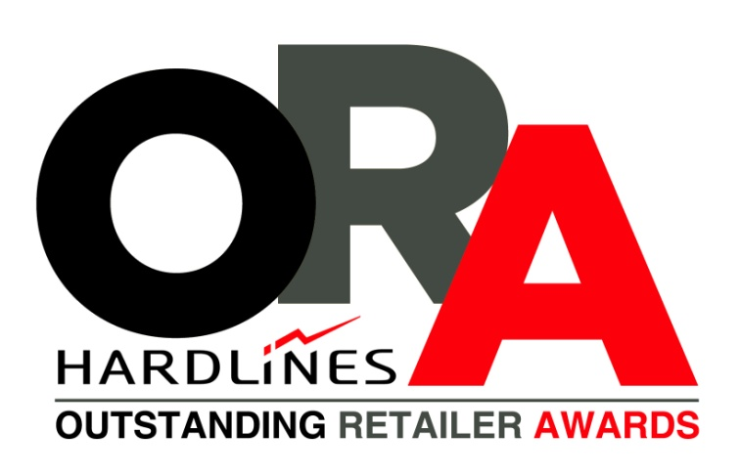

CALL FOR ENTRIES
SUBMISSION DEADLINE:
July 31, 2015

The Outstanding Retail Awards is owned and operated by:
HARDLINES INC.
Toronto, ON
M5A 1V2
416-489-3396
admin@hardlines.ca

IS YOUR STORE OUTSTANDING?
Enter the 2015 Outstanding Retailer Awards

What are the Outstanding Retailer Awards:
Launched in 1992, the Outstanding Retailer Awards (ORAs) are the industry’s only independent awards program dedicated to celebrating the achievements of hardware, home improvement and building supply dealers in Canada. In its 23-year history, the program has honoured more than 140 retailers.
Who can enter:
All Canadian home improvement retailers/dealers that have operated under the current ownership for at least two years are eligible.
Who can submit entries:
(a) Dealers may submit their entries directly.
(b) Chain/buying group head offices may choose to select their best dealer(s) and prepare their entries for them, in collaboration with the dealer. Head offices may enter more than one store per category.
(c) Vendors may identify specific outstanding retailers for entry.
How to enter:
A basic entry consists of filling out the online form, found at www.oras.ca or completing the form below. An entry can also be submitted by mailing a three-ring binder containing text and photographs describing your business successes. It is mandatory to answer fully answer all 20 questions for your application to be judged. Video and audio materials are optional. (They may be useful if you have very unusual and/or effective broadcast commercials that were made just for your business. But they are rarely the decisive factor in winning.)
Categories to enter:
1. Best Hardware Store (any size)
2. Best Building Supply/Home Centre (under 15,000 square feet)
3. Best Building Supply/Home Centre (over 15,000 square feet)
4. Young Retailer Award (a store manager 35 or under; entrants may be owners or chain employees)
5. Marc Robichaud Community Leader. This award is open to all stores. Its purpose is to celebrate the outstanding contributions/events, charitable donations, etc., made by a store’s staff/managers/owners to the community they serve.
6. Best Large Surface Retailer (over 65,000 square feet)
7. Best Contractor Specialist Store
Judging:
Judges will be looking for a variety of things, including excellence in customer service, overall store appearance, merchandising, marketing, employee management, community involvement and sales growth.
Winners will receive:
A trip to Toronto, including one night’s accommodation at the Sheraton Toronto Airport Hotel and Conference Centre, and admission to Day One of the Hardlines Conference; an inscribed plaque; a marketing package that includes a write-up in Hardlines Home Improvement Quarterly Magazine; a customized video; and photo ready to be sent to local media. The awards will be presented at a special ORA Gala Dinner, held October 21st, at the Westin Bristol Place Toronto Airport.

HOW TO SUBMIT YOUR ENTRY
Enter the 2015 Outstanding Retailer Awards

SUBMIT YOUR ENTRY ONLINE
1. Visit www.oras.ca.
2. Click the “Click here to submit your entry online” link.
3. Complete all four parts of the online submission form.
4. Submit five exterior shots, and a minimum of 20 interior ones. You can choose to upload photos of your store online in part four of the online form or you may mail a USB, CD, or printed photos to: Hardlines Inc., 528 Queen St. E., Toronto, Ontario, M5A 1V2. Photography need not be professional-quality but properly developed picture are better than printouts on laser paper. Please label all photos. Exterior shots should include signage and a view from the street or parking lot. (Building centres should include lumberyard pics.) Interior shots should include owner/manager and staff, view from the front entrance, power and other aisles, end caps, in-store promotions and contractor service desk, if there is one.
SUBMIT YOUR ENTRY BY MAIL
1. Complete the submission documents below and prepare your submission in a binder which includes:
- 2015 ORA Entry Form (Page 4 of this document).
- 20 questions answered individually (Page 5 of this document).
- Submit your photographs: Included in the binder, include five exterior shots, and a minimum of 20 interior ones (there is no maximum) on a USB CD or printed photos. Photography need not be professional-quality but properly developed picture are better than printouts on laser paper. Please label all photos. Exterior shots should include signage and a view from the street or parking lot. (Building centres should include lumberyard pics.) Interior shots should include owner/manager and staff, view from the front entrance, power and other aisles, end caps, in-store promotions and contractor service desk, if there is one.
2. Mail all of the above documents to: Hardlines Inc., 528 Queen St. E., Toronto, Ontario, M5A 1V2.
NOTES ON ALL SUBMISSIONS
1. Deadline for entries is July 31, 2015 by 5:00 pm EST.
2. Judging of the entries will be completed by a panel of industry professionals shortly after this deadline.
3. Winners and their banners/buying groups will be notified shortly after the judging.
4. Award recipients will be honoured at the 2014 Outstanding Retailer Awards Gala Dinner. October 21, 2014. At the Westin Bristol Place Toronto Airport, 950 Dixon Road. Toronto, Ontario.
5. Tickets and tables for the event can be purchased at www.oras.ca or by calling 416-489-3396.
If you have any questions regarding the general requirements
please contact Michael McLarney at 416-489-3396 or mike@hardlines.ca
Enter the 2015 Outstanding Retailer Awards
2015 ORA ENTRY FORM

Please check the category(ies) you are entering (You may check more than one):
- Best Hardware Store (any size)
- Best Building Supply/Home Centre (under 15,000 square feet)
- Best Building Supply/Home Centre (over 15,000 square feet)
- Young Retailer Award (a store manager under the age of 35; entrants may be owners or chain employees)
- Marc Robichaud Community Leader (open to all stores of any size that have made an outstanding contribution to the community they serve through a special event, a selfless act, or ongoing involvement in the community over time)
- Best Large Surface Retailer (over 65,000 square feet)
- Best Contractor Specialist Store

Store Name: __________________________________________________________________________________

Co-op or Buying Group(s) if applicable: _____________________________________________________________

Name of Owner(s): _____________________________________________________________________________

Name of Manager (if differs from above): __________________________________________________________

Street Address: ________________________________________________________________________________

Town/City: _________________________________________________Province: __________________________

Telephone: ___________________________________________________________________________________

Fax: _________________________________________________________________________________________

Email: ________________________________________________________________________________________

Website: _____________________________________________________________________________________

Entry submitted by (Name, Phone number and Email): ________________________________________________
______________________________________________________________________________________________
Deadline for entries is July 31, 2015
20 QUESTIONS TO ANSWER
Tell us about your store
1. Overview. Provide a brief (500 words maximum) personal letter from the owner/manager of the store that outlines the passion for his or her store and why the store deserves to win an Outstanding Retailer Award.  (Hint: What makes your business a leader in its local market, what are your unique strengths, why are your customers so loyal?)  Note: Questions 2-20 should have answers that do not exceed 250 words per question. Again, each question must be answered for entry.  2. History. When and how was your business founded? Has ownership changed hands? When?  3. Growth. Please describe how your business has physically expanded and/or moved. (See also Sales Growth, question 13.)  4. Size. Please describe your retail square feet, your storage square feet, and, if applicable, your lumberyard acreage.  5. Business Environment. Tell us about the town/city you serve, your estimated trading area population, the major industries, the state of your local economy, and the seasonality of your business.  6. Consumer/Contractor/Institutional Split. Please provide percentage sales for each of these three customer types. (If there are ‘other’ types of customers, please indicate.)  7. Competition. List your main competitors and their distance from you. Has big box competition recently arrived? How has this affected you?  8. Staff Count. How many full-time and part-time employees do you have?  9. Training, Compensation & Retention. Please describe how you train; your employees incentives and benefits; and your success at retaining key staff.  10. Mission Statement. If you have one, what is it? If you don’t have one, describe in a few sentences your business philosophy | 11. Customer Service. Provide some examples of ways in which your store has recently excelled.  12. Community Involvement. Describe any involvement with charitable organizations, civic events, sports, etc.  13. Top Line Sales. Please provide dollar volumes of sales, and percentage increase/decrease, for each of the last five years (or as many years as in business). Please note: the information you provide for this, and the next two questions, is strictly confidential to the judges and will not be published without your express permission.  14. Sales Per Square Foot. Please provide a three year history.  15. Turns. Please provide a three year history.  16. Retail Technology. Which system(s) does your store use and how has it improved your business.  17. Marketing. Please describe your most effective marketing techniques, especially those that are unique in your marketplace. Enclose examples of newspaper ads, flyers and transcripts of radio and TV commercials.  18. Special Events. Please describe them, whether they are recurrent or one-time events you have previously held.  19. Extensions of the Business. Please outline any successful outgrowths of your core retail business. For example (but not limited to): installed sales, commercial sales, window and door manufacturing, truss plant, homebuilding, exports.  20. Testimonials & Awards. Please provide some customer and/or business partner testimonials and/or copies of favourable correspondence that you have received from customers. If you have won civic awards, or honours within your own group, please specify.

Tell us about your store
20 QUESTIONS TO ANSWER

